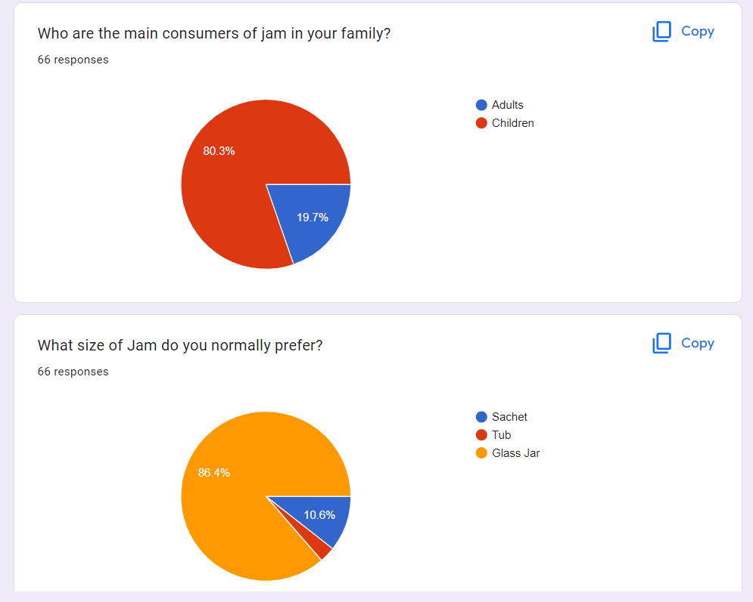

**Market Survey Research**

* According to the survey it can be seen that the main consumers of jam are children i.e., 80% of the consumers are children.

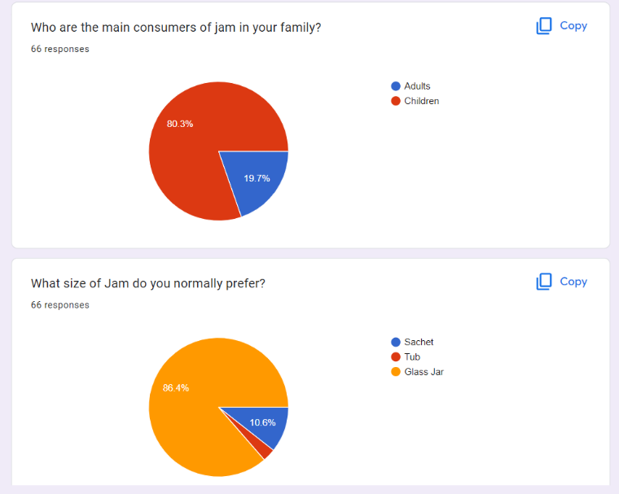

* More than 86% consumers prefer jam in glass jar more than any other packaging.

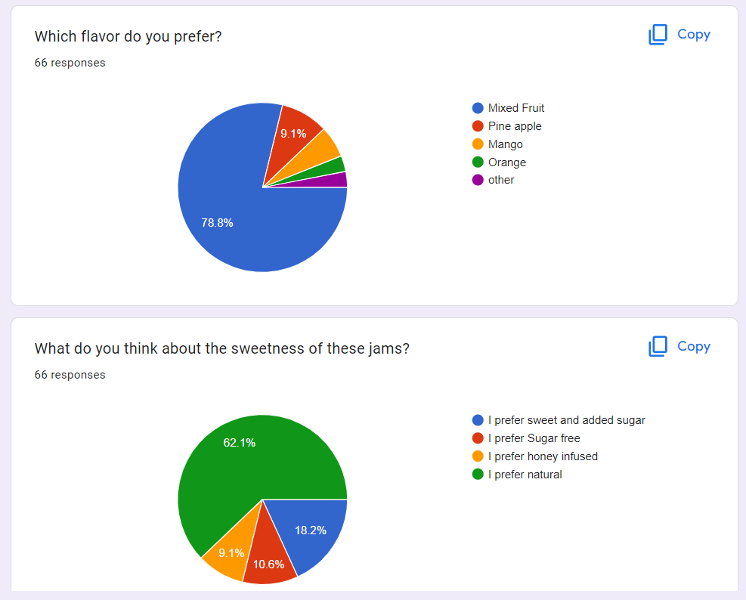

* 78.8% Consumers like Mixed Fruit flavor of jam in comparison to other flavors. Second most liked flavor is pine apple (9.1%) followed by mango, orange and other flavors.

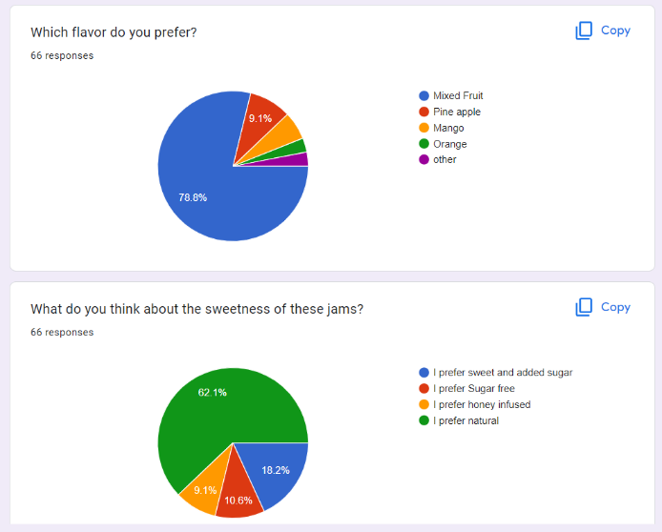

* 62.1% of the consumers prefer their jam to be natural with real flavors. 18.2% of them like sweet with sugar added in their jam. Other 10.6% like it to be sugar free while the remaining 9.1% like honey infused sweetness rather than sugar.

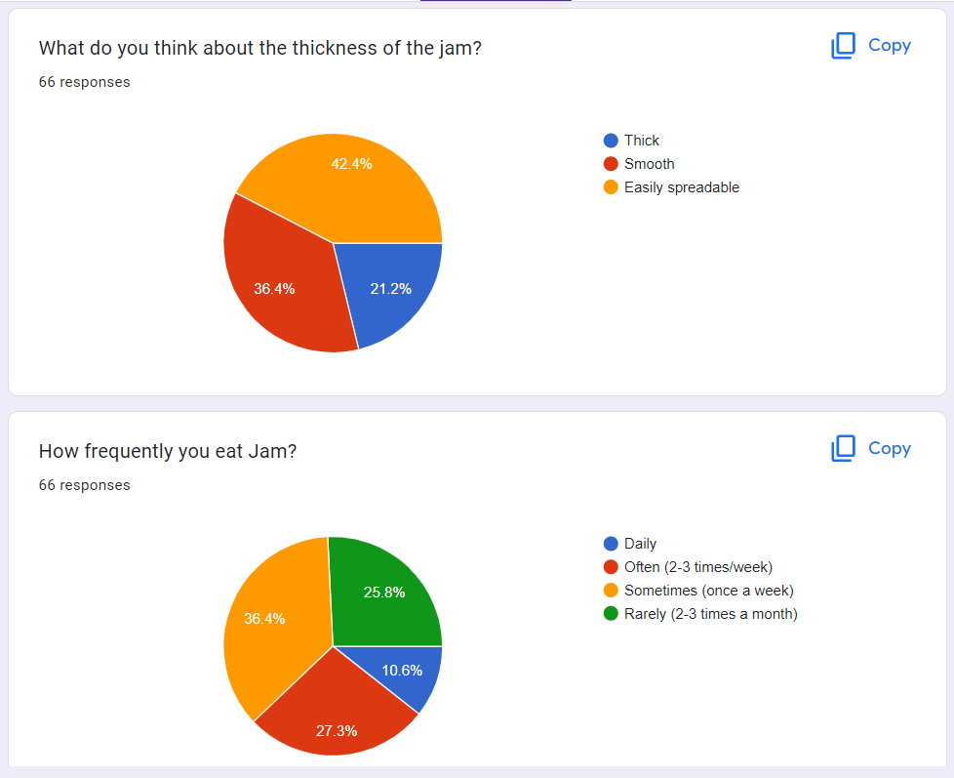

* Most consumers (42.4%) want jam to be easily spreadable while 21.2% consumers want it thick. Other 35.4% consumers want jam to be of smooth consistency.
* Maximum frequency of consuming jam is sometimes i.e.,

once a week followed by 2-3 times a week, then 2-3 times a month. There are 10% daily consumers of jam.

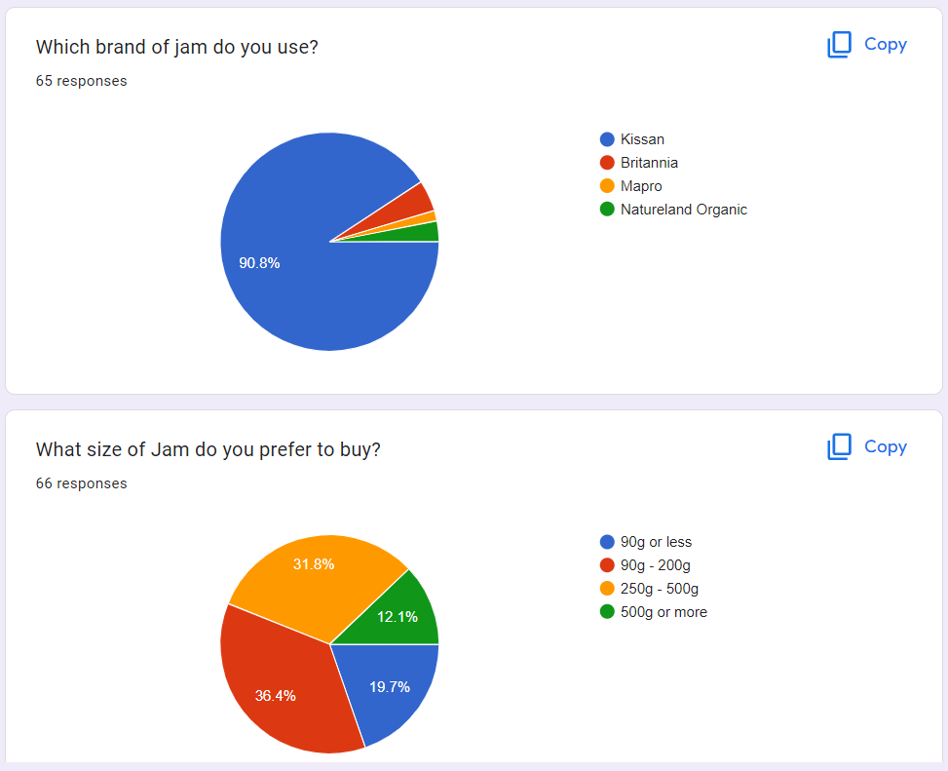

* Most selling (36.4%) size of the jam is 90g-200g. Followed by 250g-500g jar (31.8%) and 90g or less (19.7%). While 19.7% consumers buy 500g or more.

* 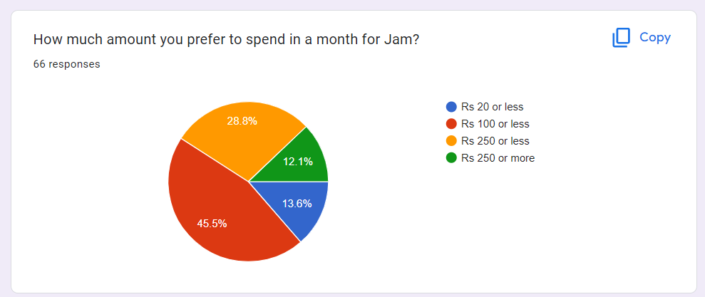45.5% of the consumers would spend Rs 100 or less in a month for jam. 28.8% would spend 250 or less. 13.6% would spend Rs 20 or less and rest 12.1% would spend Rs 250 or more.



* On the competitor’s side, Kissan stands to be greatest competitor as it is consumed by 90.8% of the consumers acquiring the maximum market. Other competitors are Britannia followed by Natureland Organic and Mapro.

**Competitor Analysis**

|  |  |  |  |  |  |  |
| --- | --- | --- | --- | --- | --- | --- |
| **Particulars** | **KISSAN** | | **NATURELAND ORGANIC** | | **MAPRO** | |
|  | Quantity | Price | Quantity | Price | Quantity | Price |
| Mixed fruit jam | 90 g | Rs. 20 | - | - ­ | - | - |
|  | 250 g | Rs. 80 | 250 g | Rs.190 | - | - |
|  | 500 g | Rs.170 | - | - | 500 g | Rs.150 |
| Pineapple jam | - | - | - | - | - | - |
|  | - | - | 250 g | Rs.210 | 250 g | Rs.72 |
|  | 500 g | Rs.180 | - | - | 500 g | Rs.144 |

* Kissan: - Kissan is a brand of Hindustan uniliver limited and its jams will be the major competitor for companies producing jams. Kissan adopted a low-price strategy for its jams to make them affordable and attracting consumers through assuring them value of money. Their main target is common masses. They introduced their jams as consistent with the basic affordable price and

different flavors while mixed fruit and pineapple being the most consumed jam in their product mix despite the competitions. It helped them to create their brand image as a household product.

The current price they are offering are –

* 15 g Sachet- Rs.
* 90 g Tub- Rs. 20
* 250 g bottle Rs.80
* 500 g Bottle-Rs. 170

Consumers mostly prefer 90 to 250 g tub or bottle of jam to buy as Kissan’s major target is mothers of small children of middle-class families for whom price plays an important role in buying decisions of a product. So, as it is the market leader in jam segmentation other competitors try to match the products prices to keep costs low for customers.

* Natureland Organics: - Natureland organics focuses on making organic and healthy jams and offering to consumers at an affordable price which is quite higher than kissan in comparison.
* Mapro: - Mapro is also a leading manufacturer of jams and its price is a little lower in comparison to Kissan and they also produce vegan and jams contain real fruit pulp to target specific consumers.

**Procedure for making mixed fruit jam:**

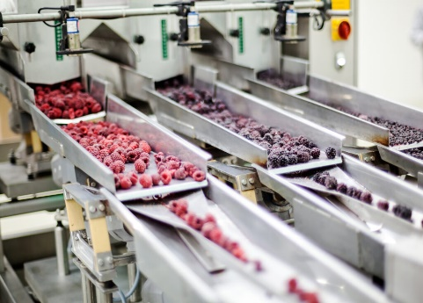

**1. Inspection**

The first step of jam production is the selection of ripe fruits. These fruits are handpicked and categorized based on their color, smell and appearance. Rotten or damaged fruits are removed.

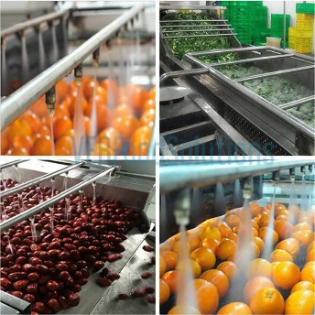

**2. Washing**

selected fruits are now washed with water containing 200 ppm of chlorine. Properties like pH and temperature are maintained. Water is not forced instead of Dump and spray washers are used in industries to prevent fruits from getting damaged.

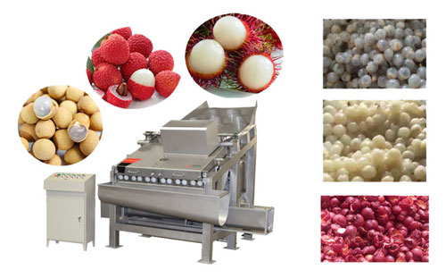**3. Peeling**

For small quantity manufacturing to the food manufacturers, fruits are peeled using hands. And for large manufacturing, a machine with blades is used for the purpose. Some fruits need not be peeled in such cased pulping is done.

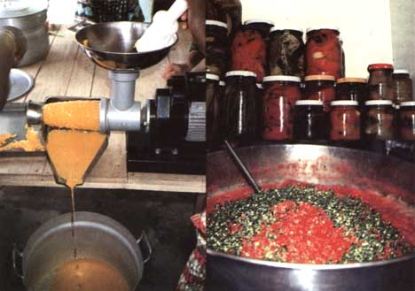

**4. Pulping**

Seeds and core part are removed by pulping. There are various kind of machines available in the market for different fruits. These machines contain blades that can be adjusted to the needed size and quantity of material to be pulped.

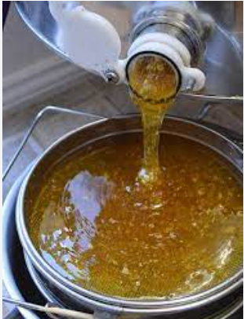**5. Addition of Honey**

Honey is added to the prepared fruit pulp in the required quantity using the suggestion of [recipe development services](https://foodresearchlab.com/what-we-do/recipe-menu-development-service/recipe-development-and-testing/). Water can be added to lower the concentration. Harder jam is made by adding more pectin and sticky jam is made by adding more sugar says the [recipe development consultants](https://foodresearchlab.com/what-we-do/recipe-menu-development-service/recipe-development-and-testing/).

**6. Boiling**

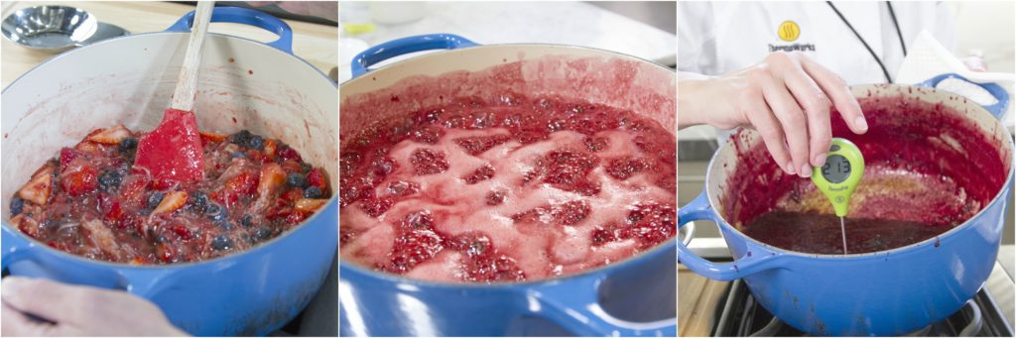One of the most critical steps in jam making is boiling, which has to be done with more patience. The prepared mixture kept on the flame. After a few mins, the sugar starts to dissolve the room is filled with a fruity smell and a network like pectin. During this process, A foamy scum can be seen forming over the layer that can be skimmed with a spoon while the mixture is cooling or butter can be added at this point to break the surface tension.

**7. Addition of citric acid**

The required amount of citric acid is added while boiling. To ensure the proper setting of jam temperature of heating is maintained at 105 C or 68-70%TSS. To check the background of the jam sheet test is conducted. Sheet test is conducted by taking a small portion of jam and cooked a little

then it is allowed to drop from the spoon if the jam drops or flakes the jam is prepared perfectly if not the jam is boiled for some more time.

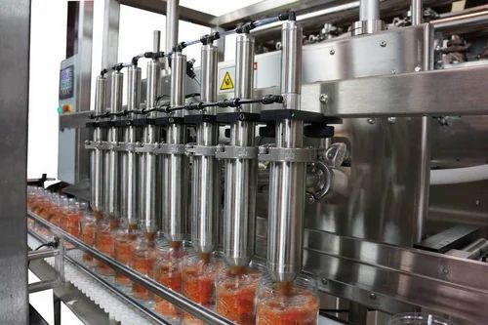**8. Filling into bottles**

Bottles are sterilized before the hot jam is poured into it, cooling of these hot bottles is done by putting it into the water bath. Paraffin wax or other waxes are used for waxing after which metal caps are vacuum capped to the bottle.

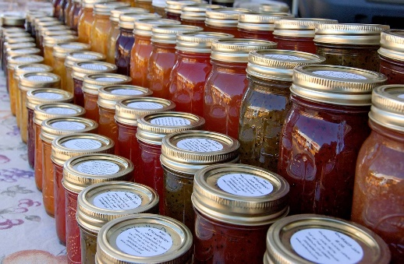

**9. Storage**

Bottled jam is now ready to be stored, and these are kept in a cool and dry place and protected from direct sunlight. Bottled jams have a shelf life of at least 12 months. The food development industry must check this properly.